

İstanbul Kültür Üniversitesi

Software Engineering

|  |
| --- |
| APXEIA  Blockchain Implementation |
| Instructor: Akhan Akbulut  Assistant: Büşra Kocaçınar |
| March 21  Authored by: Nasibullah Qarizada  Student No: 1900004691  Department: Computer Science |



Contents

Contents ii

1 Introduction 1

1.1 Project Diagram and Responsiblities - I 3

1.1 Project Diagram and Responsiblities - II 4

1 Parts Applied This Week 5

2.1 smart contract on apxiea 5

2.3 smart contract deployment 5



Project Diagram and Responsibilities

* Project Diagram

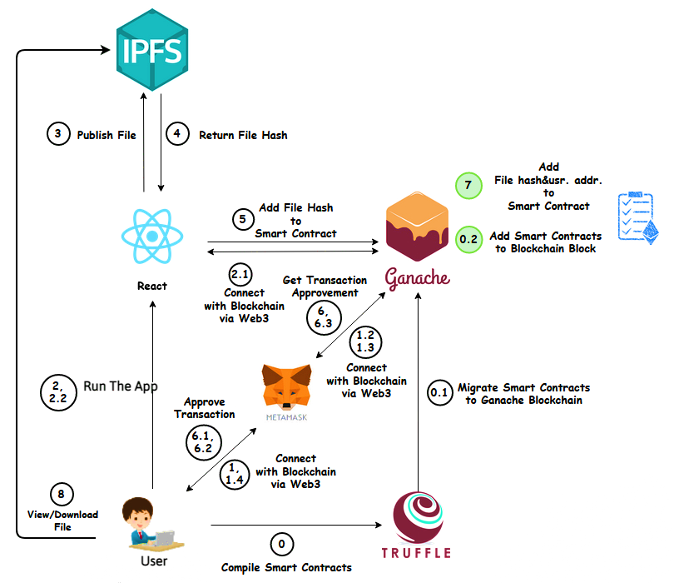



* Responsibilities

|  |  |
| --- | --- |
| Nasibullah Qarizada  Walid Abdul Hakim | Team Red |
| Sulaiman Aqaie  Ossama El Kharchy | Team Green |
| Abdurrahman Ekin  Mehmet Tugrul Arasan | Team Blue |

Parts Applied This Week

* Smart Contract Deployment
* Smart contract has been wrote with Solidity Programming Language.
* Below smart contract will help us with:
* Receiving files, confirming data types and information and trigger the functions to store on IPFS.
* Fetching hashes with IPFS.
* In upcoming days we will try to pass the smart contract to the blockchain with truffle and ganache.

